

**Newsletter January 2022**

Get the latest information about the Local Land Charges (LLC) Programme and the migration of local authorities’ data to the central LLC Register.

**In this month’s edition**

* Highlights of 2021
* Supporting innovation
* Welsh translation available
* Upcoming events
* Service statistics
* Feedback



**Allison Bradbury, Head of Local Land Charges Implementation**

**Highlights of 2021**

* Sixteen local authorities migrated to the Local Land Charges (LLC) Register in 2021. This quickening pace of migrations highlights a smoother migration process and increased financial support. In total thirty 30 local authorities have now migrated their LLC service to the national register.
* In May we announced new LLC funding for local authorities. The £26 million transition fund aims to help authorities migrate their LLC service faster, by covering **incidental costs which could cause delays. Local authorities will receive two separate transition payments when:**
* the Collaboration Agreement is signed; and
* their LLC service transfers to the LLC Register by the agreed delivery date.

**Twenty-five local authorities have received both transition payments, enabling them to** address practical resourcing needs and speed up the migration process. **Seventeen authorities have received their first transition payment and are now able to source the assistance they require.**

* In June, we increased our migration capacity by partnering with two new Migrations Services Delivery Partners. [Cyient Europe](https://www.cyient.com/) and [Landmark Information Group](https://www.landmark.co.uk) have responsible for the overall transformation of local authority LLC data, which includes the discovery of charges, scanning and digitisation. We expect to see even more local authorities transferring their services to the LLC Register in 2022, as we begin working in tandem with our new partners.
* Following collaboration between the Welsh Government and LLC Programme, the Local Land Charges (Fees) (Wales) Rules 2021 was introduced in April 2021. The legislation allowed Welsh LLC search fees to be aligned with England, paving the way for Welsh authorities to transfer their LLC service to the national register. Ten months later all 22 Welsh authorities have started their migration journey. And will soon have an opportunity to benefit from the speed and simplicity of a fully digital register, along with their customers.
* In November, the Local Land Charges Programme won the coveted Digital Leaders 100: Geospatial Innovation of the Year award, making it a recognised digital leader. The award celebrates individuals and organisations from the public, private and non-profit sectors who demonstrate a pioneering and sustainable approach to digital transformation in the UK. More than 23,000 votes were cast for the finalists.
* The [Migration Hub](https://landregistry.github.io/local-land-charges/migration) formally launched in May, following the closure of the GitHub platform. The site aims to provides local authorities with end-to-end support and guidance during the migration of their LLC service to the national register.

A comprehensive collection of templates, guides, videos, case studies and training material is available to assistance authorities at every stage of their migration journey. To make access to the information simpler, we are continuing to refine the Hub based on user feedback.

* In October the LLC Register recorded its one millionth charge. This significant milestone illustrates the increasing pace of migrations. Two months later more than 1.5 million charges from 30 local authorities are now held on the register.

**Supporting innovation**

From spring we are hoping entrepreneurs and start-up businesses who are selected for the [Geovation Accelerator Programme](https://eur03.safelinks.protection.outlook.com/?url=https%3A%2F%2Fgeovation.uk%2Faccelerator%2F&data=04%7C01%7CJackie.Lynch%40landregistry.gov.uk%7C671008d7ff78427a47e408d9d6a10c36%7C236309a8284b4e57a7b3fc767736f69d%7C0%7C0%7C637776809437845942%7CUnknown%7CTWFpbGZsb3d8eyJWIjoiMC4wLjAwMDAiLCJQIjoiV2luMzIiLCJBTiI6Ik1haWwiLCJXVCI6Mn0%3D%7C3000&sdata=Mbj5BmRRYAqmpijGRlvs1Ehzc9BrVJf%2FRQPqPJ%2FFm1E%3D&reserved=0) will be able to access to Local Land Charges Register dataset.

The Accelerator programme is dedicated to supporting PropTech (property technology) and GeoTech (geospatial technology) start-up companies who develop innovative ideas. Funded by us and Ordnance Survey it is being used to unlock the hidden value in our organisation’s datasets, for the benefit of the wider UK economy.

Successful candidates are given:

* up to £20,000 grant funding;
* access to HM Land Registry’s property datasets;
* access Ordnance Survey location-based datasets; and
* 6 months intensive, bespoke support.

We are continually assessing how LLC data can be used wider to support the housing market, while maintaining security. A current appraisal will determine if Geovation candidates can have access to elements of LLC dataset in spring.

**Welsh translation available**

Welsh customers who use the Local Land Charges Register will be able to access information in Welsh and English, when Welsh authorities transfer their service. With coding complete customers can now choose their preferred translation when requesting searches.

**Upcoming events**

We are kickstarting the new year with a new webinar, which will be presented on 26 January and 1 February 2022. This webinar will give an update on migration progress and aims to prepare authorities for their migration journey.

[Click here to register](https://attendee.gotowebinar.com/rt/5702194165187881229)

The webinar will cover:

* where are we now?;
* what we have achieved?;
* our latest processes;
* what happens to your LLC data before, during and after migration?;
* the regional cluster approach to migrations;
* testimonials and lessons learnt by migrated authorities; and
* live Q & A session

We look forward to seeing you at the event and answering your questions.

**Service statistics**

This graph illustrates the number of [official searches](https://search-local-land-charges.service.gov.uk/) purchased through HM Land Registry’s business channels for migrated local authorities.

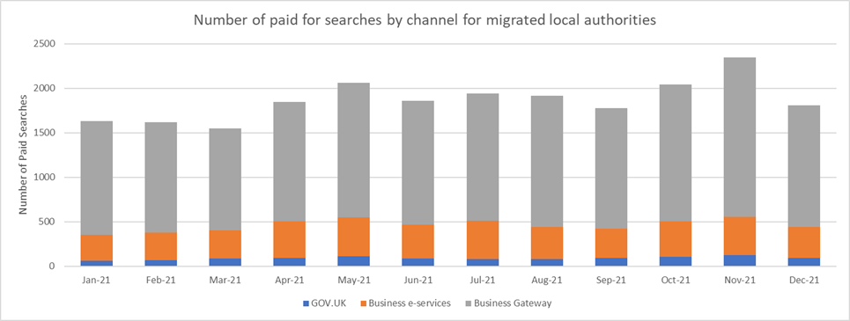

[Sutton and Plymouth](https://www.gov.uk/government/publications/hm-land-registry-local-land-charges-programme/local-land-charges-programme) are the latest councils to join the [national LLC Register](https://search-local-land-charges.service.gov.uk/), bringing the total number of migrated authorities to 30. The search trend decreased in December when many organisations closed for Christmas.

**Feedback**

Your feedback is important to us and will be used to improve and refine our service. Please [contact our team](mailto:llcproject@landregistry.gov.uk) with your comments.

Kind regards

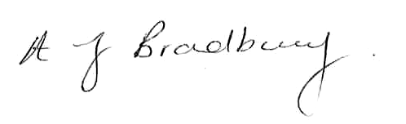

**Allison Bradbury - Head of Local Land Charges Implementation**

[llcproject@landregistry.gov.uk](mailto:llcproject@landregistry.gov.uk)